
HARROW COUNCIL

ADDENDUM

PLANNING COMMITTEE

DATE: 19th January 2022

2/03 | 15 Formby Avenue – P/4077/21  Appendix 4, Figure 15 is amended as follows to reflect the proposed site layout.  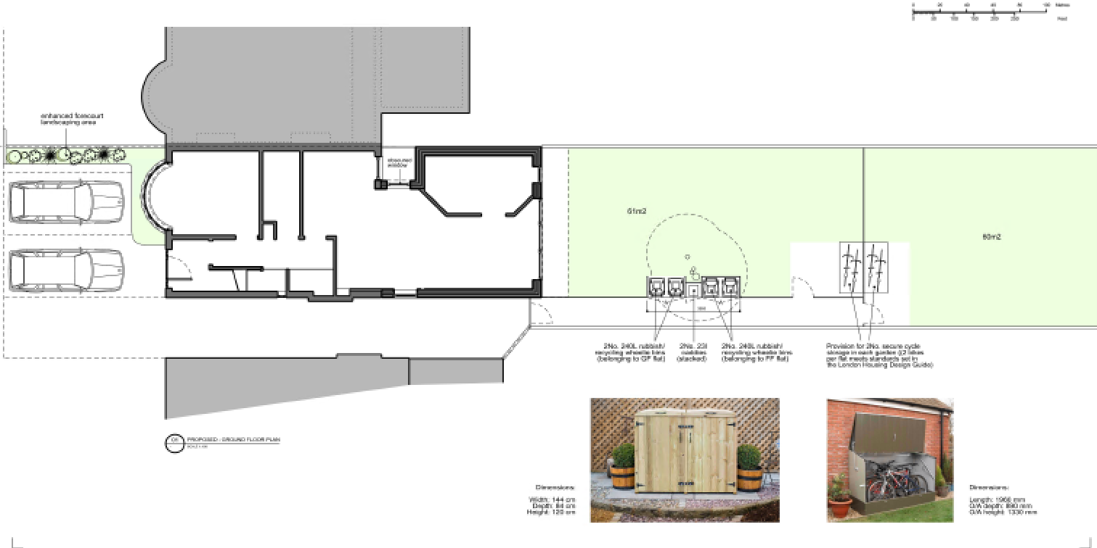
2/05 | 87 Lankers Drive – P/4226/21  Add additional text to very end of paragraph 6.2.3 stating the following:  Whilst officers do not raise an in-principle objection to its incorporation, limited information has been provided on the external appearance and colouring of the proposed ‘aluminium standing seam metal roof’. To ensure that its detailed appearance is satisfactory, a condition has been imposed requiring the applicant to submit material samples for the proposed roof.  Alter the wording of Condition No. 3 (Materials) within Appendix 1  From:  The external surfaces of the development hereby approved shall be constructed in accordance with the details provided within PL-A-01 and the submitted Application Form.  REASON: To safeguard the character and appearance of the area in accordance with Core Policy CS1.B of the Harrow Core Strategy (2012) and Policy DM1 of the Harrow Development Management Policies Local Plan (2013).  To:  Notwithstanding the details shown on the approved plans, the development hereby permitted shall not proceed above ground floor damp proof course level until samples of the proposed extension’s ‘aluminium standing seam metal roof’ have been submitted to, and approved in writing by, the local planning authority. The submitted details shall indicate the external appearance and colouring of the proposed roof. The development shall be completed in accordance with the approved details and shall thereafter be retained. Other than in the case of the roof of the extension, the materials to be used in the external surfaces shall match those used in the exterior of the existing building.  REASON: To safeguard the character and appearance of the area in accordance with Core Policy CS1.B of the Harrow Core Strategy (2012) and Policy DM1 of the Harrow Development Management Policies Local Plan (2013).
2/06 | At the Reasons for the Recommendations section of the report this has been amended to outline previous planning application reference.  REASON FOR THE RECOMMENDATIONS  The principle of introducing housing provision on the application site has already been established as acceptable through the grant of outline planning permission (reference P/1017/CFU) for a residential development of 6 retirement flats which was allowed on appeal and subsequent application under P/3720/08 and recent application under reference: P/0898/19 P/0089/20. Since these decisions there has been no policy changes on this matter.  The recent appeal decision of the previously refused scheme under ref: P/0898/19 P/0089/20 the Planning Inspector considered the scheme to appropriately relate to the site, local context, massing and architectural appearance and would bring forward housing provision of a satisfactory layout and design to ensure that the future occupiers would benefit from an acceptable standard of living accommodation. The current scheme is broadly similar identical (with the omission of the roof terraces) to the previous scheme and it would be unreasonable to warrant a refusal on this basis as the remaining objections relating to the appeal have been overcome.  At Paragraph 2.3 the details of the layouts of the proposed dwellings have been clarified.  The houses are arranged with sleeping accommodation at ground floor level and living areas at first floor level at plots 1 to 5. The sleeping accommodation would be at first floor level with living areas at ground floor level for plots 6 to 9. The proposal would maintain level access to each dwelling.  At Paragraph 2.7 and 2.8 the details of the changes to the previous scheme which is being maintained by the current proposal and outlining the previous planning refusal reference.  The amendments made to the scheme from the previous scheme involves the removal of balconies to the block which faces properties along this section of Whitchurch Lane and the reduction in the footprint of the terrace building adjacent to the northern boundary by omitting 1x dwelling and providing 4x car parking spaces were made as part of the previous refused scheme under planning ref: P/0089/20 which is maintained by the current scheme. The building adjacent to the north western corner accommodates two dwellings (labelled as Plot 1 and 2) previously it accommodated only 1x dwelling Plot 1 .  The proposed new building subject of this application features the same storey height, siting, positioning and massing proportions as those for the previously proposed for 9 units on the site and which was refused under planning permission reference P/3109/20 P/0089/20 and at Appeal the Planning Inspector considered the design, layout to be acceptable and the amenity impacts to be minimal. The Inspector dismissed the appeal on the basis of the amenity impact on from the proposed terraces facing residential properties along Whitchurch Lane. As mentioned above, these terraces have been omitted from the proposal to address concerns of overlooking and loss of privacy of these adjacent residential properties.  At Section 3.0 the Planning History has been amended as follows to outline previous application reference and reasons for refusal which was again dismissed at appeal on the grounds of amenity impact.  RELEVANT PLANNING HISTORY  The Consultee section has been amended as follows to reflect previous application (under ref: P/0089/20) comments  The following consultations have been undertaken and a summary of the consultation responses received are set out below.  At paragraph 6.2.6 the previous application is clarified.  In addition, the principle of development for residential use has also been established under planning ref: P/1017/CFU for the outline permission for 6 retirement flats which was allowed at appeal and subsequent application under planning reference: P/3720/08. This was also reiterated in the previous applications under ref: P/0898/19 and P/0089/20. There has been no change in policy since this time which would warrant a different conclusion.  At Paragraph 6.3.2 and 6.3.3 the application references of the previous schemes and their details have been clarified.  The site comprises a vacant parcel of land in area to the rear of Whitchurch Lane. The Council has previously refused a scheme for 9 units under planning ref: P/0898/19 P/0089/20 which has a similar the same site layout, scale and massing to the current scheme. The Council considered that the proposed layout and siting of the units leaves limited gaps to the boundaries of the site with no defensible space. However under Planning Appeal ref: APP/M5450/W/20/3258877 the Planning Inspector considered that ‘the layout of the proposed development positively responds to the constraints of the site in a simple and logical manner’.  The proposed layout is broadly the identical to as the previous scheme under ref: P/0089/20, where the gap between building labelled Plot 1 and Plot 3 are increased with the omission of plot 2 and the proposed building footprint of Plot 1 has been increased with the addition of plot 2 with the building abutting the western side boundary from the 2019 scheme under planning ref: P/0898/19. The proposed building accommodating Plots 1 and 2 also maintains a similar set back from the northern boundary as the block accommodating Plots 3- 5. The Therefore the layout is considered appropriate and it would be unreasonable to warrant a refusal on the basis of the Inspector’s decision.  Figure 1 is amended as follows to reflect the previous appeal site layout.  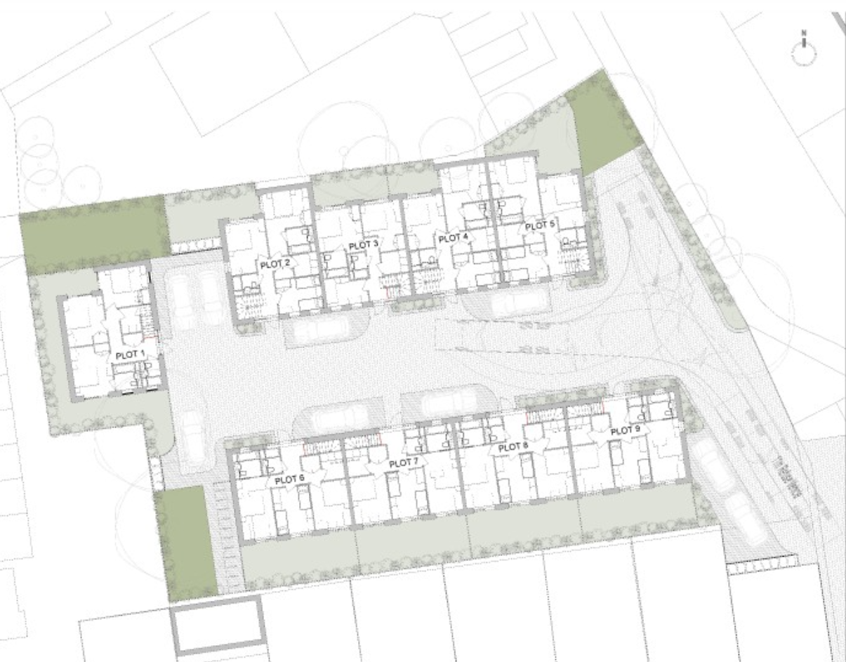  Appeal scheme layout 2019  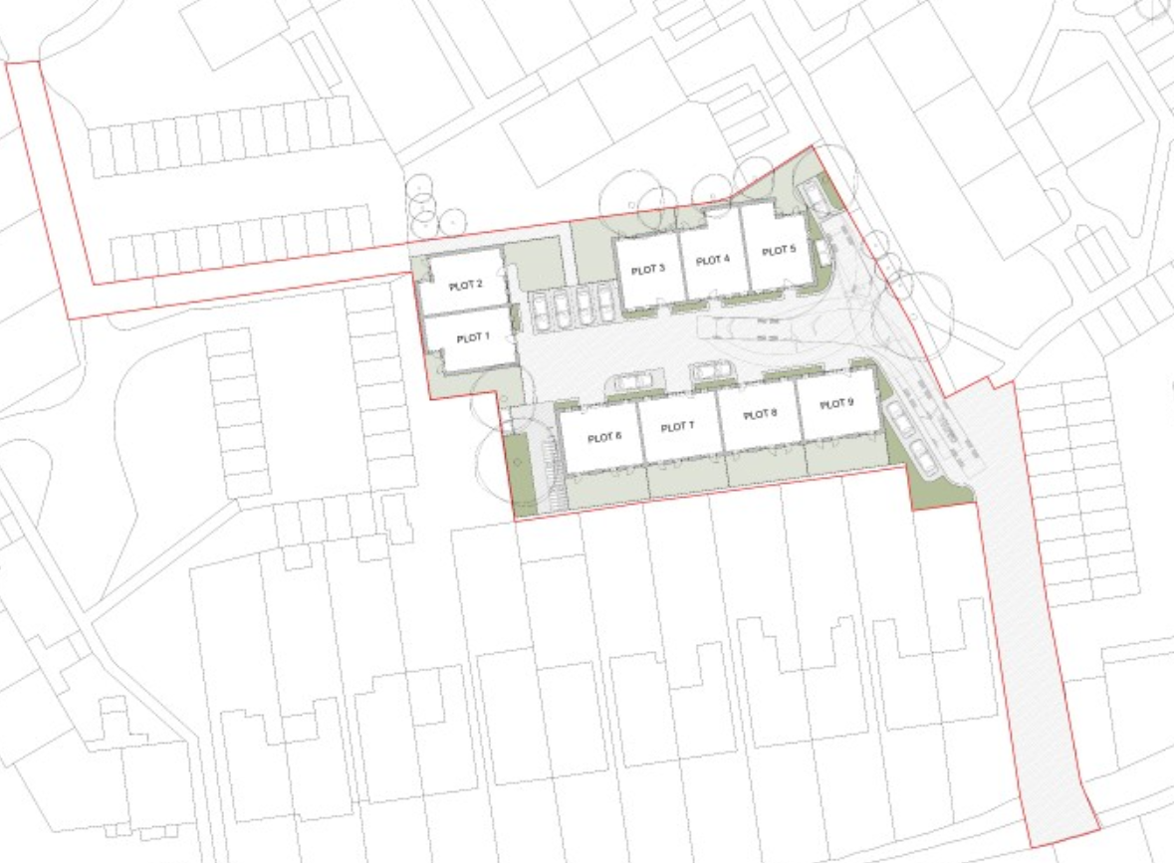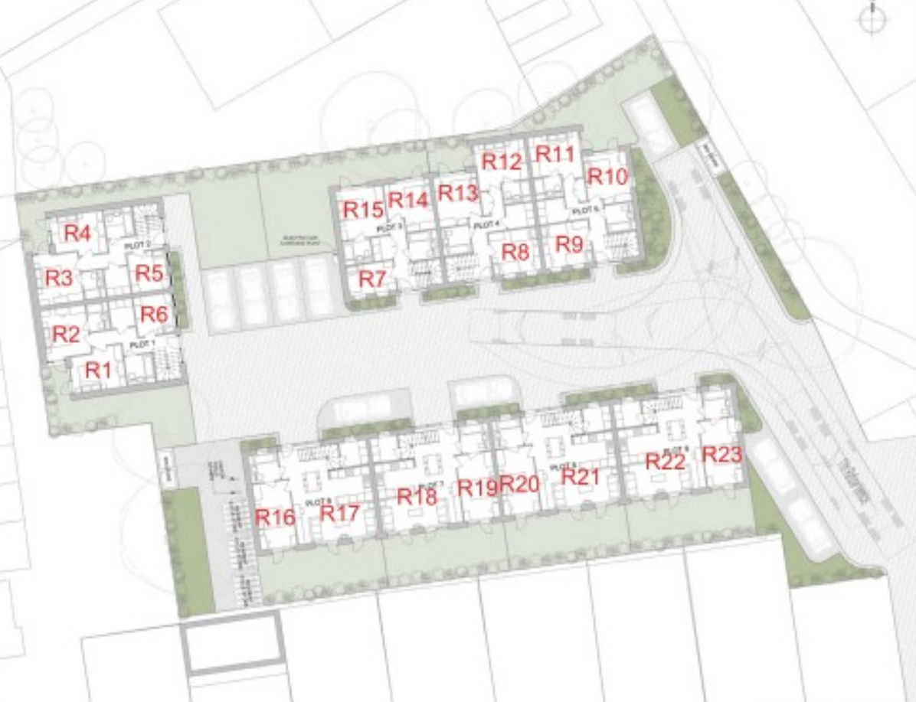  Appeal Scheme layout 2020 Proposed layout  Figure 1 – comparison of previous and current layouts  At Paragraphs 6.4.6 the Planning Inspector’s decision has been added in reference to the amenity impact.  The proposal provides Plots 1 and 2 with terraces at first floor level. Given the siting of Plot 2 and its separation distance from Dudley House it is not considered to result in any significant impact on Dudley House in terms of loss of privacy or overlooking. In addition, the terrace for Plot 1 would be situated to the south east corner of the building and would face the hard surfaced area of the site and would not result in any impact on adjacent properties in terms of loss of privacy or overlooking. This was also considered acceptable at appeal by the Planning Inspector as part of the previous refused scheme.  At Paragraph 6.4.10 the curved roof is clarified.  In terms of actual and perceived overlooking and loss of privacy of these existing properties at nos. 123 to 135 Whitchurch Lane, the previous scheme was refused and dismissed at appeal on this basis where the development featured first floor terraces which would overlook the neighbouring gardens of these properties along this section of Whitchurch Lane. The proposed scheme omits the terraces and maintains a stepped first floor level to the building where the curved flat roofed area would not be accessible for the units. A condition is recommended to ensure that the flat roofed area is restricted from any use as terraces/balconies for the proposed units. On this basis the proposal has overcome the impact on neighbouring properties in terms of loss of privacy and overlooking.  At Paragraph 6.5.4 it is clarified that the proposal maintains the 4 car parking spaces as the previous appeal scheme.  The proposal has repositioned maintained the 4 of the car parking spaces to the northern side of the site between Plot 2 and 3 to 5 as the previous scheme. The two of the spaces are to have electric vehicle charge points whilst the rest will be passively supplied. A condition is recommended for the submission of a car park management plan detailing the layout, the process for activating passive EV charge points, management and enforcement. A previous proposal for this site raised concerns about manoeuvrability and safety; these have been addressed with the inclusion of inward opening doors within recessed accesses and relocated parking spaces. Therefore, Officers consider these changes to be acceptable
  Ref no. | Description | Status & date of decision
  P/0089/20 | Re-development to provide nine two storey dwellinghouses (9 x 3 bed); Separate amenity space; Parking; Boundary treatment; Landscaping; Refuse and cycle storage  Reasons for refusal:  1. The proposal, by reason of its siting, form, massing and bulk, in addition to its curved roof form and abundance of hardstanding, would represent poor quality design which would appear as a visually cramped form of overdevelopment and would fail to respect, relate and respond to the character, appearance and pattern of development surrounding area, contrary to the high quality design aspirations of the National Planning Policy Framework (2019), policies 7.4B and 7.6B of The London Plan (2016), Policy D1 of the Draft London Plan (2019) Core Policy CS1.B of the Harrow Core Strategy (2012); Policy DM 1 of the Harrow Development Management Policies Local Plan (2013) and the adopted Supplementary Planning Document: Residential Design Guide (2010).  2. The proposed dwellinghouses 6-9 by reason of their siting and proximity to the shared boundary and positioning of terraces on the first floor rear elevations and overall width and scale, would have an unacceptable overlooking impact and loss of outlook on the occupiers of 125-133 Whitchurch Lane, to the detriment of their visual and residential amenity, contrary to the Policy 7.6 of The London Plan (2016), Policy D1 of the Draft London Plan (2019), Policy DM 1 of the Harrow Development Management Policies Local Plan (2013) and the adopted Supplementary Planning Document: Residential Design Guide (2010).  3. The proposed dwellinghouses 1 and 2 by reason of their siting and proximity to the shared boundary, will prejudice the development of the site to the west contrary to the National Planning Policy Framework (2019) Policy 7.6B of The London Plan (2016), Policy DM 1 of the Harrow Development Management Policies Local Plan (2013) and the adopted Supplementary Planning Document: Residential Design Guide (2010).  4. The proposed dwellinghouses 3-5, by reason of their siting and proximity to the shared boundary, will have an overbearing and enclosing impact to the garden area serving Dudley House to the north of the site to the detriment of the residential amenity of the occupiers of the flats, contrary to the Policy 7.6B of The London Plan (2016), Policy D1 of the Draft London Plan (2019), Policy DM 1 of the Harrow Development Management Policies Local Plan (2013) and the adopted Supplementary Planning Document: Residential Design Guide (2010).  5. The proposal, by reason of the lack of windows in the rear and/or side elevation for dwelling houses 1-5 would result in a poor standard of living accommodation for future occupiers in regards to adequate levels of natural light and outlook to the upper floor rooms. The proposal is therefore contrary to the National Planning Policy Framework (2019), Policies 3.5 and 7.6B of The London Plan 2016, Policy D4 of the Draft London Plan (2019) Policy DM1 of the Harrow Development Management Policies Local Plan (2013), the adopted Supplementary Planning Document Residential Design Guide (2010).  6. The proposal fails to demonstrate that adequate refuse storage to serve the development can be accommodated on the site to the detriment of the character and appearance of the area and residential amenity of the potential occupiers of the dwelling houses. The proposal is therefore contrary to 7.4B and 7.6B of the London Plan (2016), Policy D4 of the Draft London Plan (2019), Core Policy CS1R of the Harrow Core Strategy (2012) and Policy DM1 of the Development Policies Local Plan (2013). | Refused:  06.03.2020  Appeal Dismissed:  18.05.2021
  Consultee and Summary of Comments
  LBH Highways
  Given the direct relevance of the previous planning decision under ref: P/0898/19 P/0089/20 to this application proposal, a text of the previous comments from the Highways Team is reproduced below in italics and comments for this application follow after.
  Comments for P/0898/19 P/0089/20:
  This proposal is within a PTAL 2 location however, it is served by regular buses; Canons Park station is within walking distance and Edgware town centre can be easily reached by cycle, on foot or bus where there are further public transport options.
  Car ownership levels show that 66.8% of properties have access to one or more cars or vans according to Census 2011 data. The proposal seeks to provide 9 car parking spaces for the 9 houses. The new draft London Plan maximum parking standards allows for a maximum of 1 parking space per dwelling in a PTAL 2 area, therefore the proposed level of parking is policy compliant however no disabled parking or electric vehicle charge points are shown but are required.
  The parking layout shows four of the spaces being between the entrances to the houses. Whilst flows and speeds are going to be low at this point, a door opening onto a road or parking space is not ideal and a safe recess or some kind of protection from a manoeuvring vehicle would be preferred.
  Further information on the shared surface access road is required. There are no drawings showing a detailed layout from Whitchurch Lane to the site. The applicant is advised to refer to the Harrow Street Design guide. What measures are proposed to prevent injudicious parking by residents or commuters etc? A pedestrian route from Stratton Close is also to be provided but there are no plans showing details of this; would it be lit and can it be accessed by the general public as this will create a through-route from Whitchurch Lane.
  The cycle parking details need to be further clarified and improved. Each house must have a minimum of two cycle parking spaces and a further minimum of two separate, short stay cycle parking spaces for visitors must also be provided. The applicant is advised to take note of Chapter 8 of the London Cycle Design standards and provide good quality, secure, sheltered and accessible.
  The revised parking layout is an improvement on the previous proposal however, the waste team will need to review this too in order to ensure that it meets their needs. Details of the type of cycle storage for a minimum of 18 long stay spaces and two short stay spaces should be secured by pre-occupation condition. A Construction logistics plan needs to be secured by pre-commencement condition. A minimum of two electric vehicle charge points and 7 parking spaces with passive provision must be provided. Details of the type of charge point and their locations must be secured by pre-occupation condition. A Highways agreement will be required to allow alterations to the vehicle crossing to be made. Provided the above requirements are met, Highway have no objection to this proposal
  The submitted plans address the above concerns, which the Highways Team have considered to be acceptable. The current comment below are in relation to these latest drawings.
  Comments for this application:
  the London Plan 2021 (Policy T6.1) maximum of 1 space per dwelling in a PTAL 2 location.
  Census 2011 car ownership levels for this location indicate that 66.8% of households have access to at least one car or van.
  The proposed level of parking is acceptable. Two of the space are to have active electric vehicle charge points whilst the rest will be passively supplied. A car park management plan should be supplied detailing the layout, the process for activating passive EV charge points, management and enforcement.
  It is proposed to take vehicular access from the existing facility connecting with Whitchurch Lane which will operate as a shared surface. The access road is to be widened from 3.7m to 5.5m and will require an extension to the existing vehicle crossing and footway too in order to accommodate waste collection vehicles. Swept path drawings have been provided which demonstrate that a refuse lorry can access the site and enter and exit in a forward gear. It is important that parking within the site is restricted to the identified locations shown on drawing no. 18201-00-004 Rev E, otherwise it may be difficult to turn HGVs – details of how this will be managed must be provided in the parking design and management plan.
  A previous proposal for this site raised concerns about manoeuvrability and safety; these have been addressed with the inclusion of inward opening doors within recessed accesses and relocated parking spaces. These changes are acceptable.
  Cycle Parking:
  The proposal includes a communal Bike hangar store for up to 18 cycles and two Sheffield stands for visitors. This level exceeds the minimum requirements of the London Plan 2021 policy T5 which requires at least two spaces per dwelling and two visitor spaces.
  Summary:
  This proposal is unlikely to result in a severe or harmful impact for the surrounding highway network, subject to conditions, Highways have no objection.
  LBH Urban Design Officer
  No comments provided for were provided where the design is similar to P/0089/20, however comments for P/0898/19 for a similar scheme are outlined below:
  The approach to the scale of the development and the mews house typology is well considered. Questions the curved roof as the proposal already sits lower than peripheral dwellings. Unnecessary and compromises on the potentially generous head room to the kitchen/living/dining room area.
  The landscape is dominated by cars, with poor outlook from ground floor bedrooms facing onto parking bays.
  Bin stores are currently dispersed across the site; is it possible to consolidate some of these.
  The internal configuration of the dwellings is well organised and generously planned, particularly to all open plan living arrangements on upper floors with terraces.
  It would be good to see some glazing to the stairwells, as shown on Plots 2-5, applied to the remaining units. The ground floor could feel quite dark, and this move could help bring further natural light in.
  Questions how ventilation works to landlocked rooms, namely utility rooms and bathrooms on the party wall to Plots 2 – 5, and utility rooms to plots 6 – 9. It would be good to see a ventilation strategy going forward, and how these ducts/penetrations work on key elevations.
  The plans indicate turning zones for wheelchair users; Suggests flipping the accessible bathroom (currently allowed for as an ensuite to Bedroom 1) with the communal bathroom, as the communal bathroom is better suited for DDA access requirements.
  House Type 2 Level 0: Accessible bathroom (communal) should be at least 3.6sqm, wheelchair WC with shower, as per London Housing Design Guide. Bedroom 3 should also be 12sqm, not 10sqm as currently shown, also as per LHDG recommendations.
  General comments on House Type 3 Level 0: Bedroom 3 should be 8sqm not 7,
  as per LHDG. Similarly to above, increase communal bathroom to 3.6sqm or demonstrate that there is adequate turning for wheelchair users. There also appears to be a clash with the turning circle in the entrance hall and the storage wall door; it would be good to see this wall/storage door set back further.
  It would be good to see an indication of window locations to first floor, especially to kitchen area. Is it possible to continue the glazing to stairwells where possible at upper level.
  Good to have living on upper level, with large terrace.
  There is very little information on materiality; except for white render walls, and standing seam roof in unknown material. High quality aluminium frames are expected as standard, and preferable to low quality uPVC.
  Soft landscaping and terraces as garden space is supported. Detailing of the balustrade and the material choice (currently unknown) to the dwelling partitions is questioned. Deep planters are welcomed, but would be difficult to maintain if set against a 1100 rail balustrade; perhaps omitting the railings entirely and bringing the planters to cill height could work better
  Comments for this application:
  The two storey scale of the development is supported.
  The layout of a mews style development which faces principally inward and away from surrounding development is supported.
  There is little daylight and sunlight impact on neighbouring properties. Both are within BRE guidelines. There is no major overbearing impact in regards to plots 1 and 2 and plots 4 and 5 abutting the boundary to the west and north respectively.
  There is some concern regarding the quality of amenity spaces and waste storage to the western side is not supported.
  There is limited concern with ground floor internal layout and all units are dual aspect, with potential for through ventilation to address overheating.
  House Type 1 (Plots 1 and 2) have successful internal layouts. It is positive that the first floor lacks certain aspects, to reduce overlooking to the west, which in any case is mitigated by a large portion of glazing onto an inward-facing terrace. There may be scope to introduce a small window opening in the northern and southern elevations to address passive ventilation. Rooflights may also be introduced.
  House Type 2 (Plot 3) and House Type 3 (Plots 4 and 5) are of an equally high internal quality, with orientation and aspect of the upper storey addressing overlooking concerns and south-facing terraces supported.
  The Applicant should consider removal of the third bedroom to increase rear garden size. Likewise, the parking space adjoining Plot 5 should be removed to offer a more regularly shaped rear garden for this plot.
  There is little planting to the courtyard and significant potential for this to add richness to the space and to be used for screening and defensible space.
  The use of roof material is supported and the provision of a second storey, which appears as a habitable roof space helps to mitigate massing and built form impact. There is still concern raised regarding the curved roof profile which appears largely incongruous with existing dwellings to the south and west. A simple roof form is recommended (simple pitch).
  There is large amount of glazing within the first floor within the southern elevations of plots 6 -9 and raises concerns regarding overlooking of nos. 123 – 139 Whitchurch Lane. Amendments recommended to address this.
  There is little detail regarding elevation treatment in terms of fenestration as are the western and eastern elevations to plots 1-2 and the wider site.
  LBH Drainage
  Comments for P/0898/19 P/0089/20:
  The Flood Risk Assessment submitted by the applicant is fine. The following need to addressed.
  Please note that there is a piped watercourse located within the site, irrespective of planning permission the applicant will need to apply for a Land Drainage consent for undertaking any works within 5m of the piped watercourse and pipe protection will be required. Detailed drainage design in line with our standard requirements should be submitted. Insufficient volume of storage has been proposed. A minimum of 100m3 of storage is required. The applicant should consult Thames Water developer regarding capacity of their public sewers for receiving discharge from the proposed development. The Thames Water confirmation letter should be submitted. Permeable Paving - The applicant should submit a cross section of permeable paving construction with full details and their maintenance plan for our approval.
  - Flood Plain:
  The applicant has mentioned in the FRA that there would be no loss of flood plain. Please can you request them to provide proposed ground levels within the floodplain to prove the statement.
  - Drainage Strategy :
  - Insufficient volume of surface water storage has been proposed. For 2 l/s discharge restriction a minimum of 100m3 of storage is required.
  - Please note that 20mm orifice plate is prone to blockages, hence a hydrobrake should be used.
  - The applicant should submit drainage details in line with our standard requirements attached.
  - The applicant should contact Thames Water developer services by email: developer.services@thameswater.co.uk or by phone: 0800 009 3921 or on Thames Water website www.developerservices.co.uk for foul drainage connection approval.
  The further information can be conditioned with our standard pre commencement drainage conditions for surface water disposal. Foul water disposal, surface water attenuation and storage.
  - Piped Watercourse:
  Please note that there is a piped watercourse located within the site, irrespective of planning permission the applicant will need to apply for a Land Drainage consent for undertaking any works within 5m of the piped watercourse and submit pipe protection details for our approval.
  Please find attached our standard notification & requirements letters sent to the applicant’s agent for your reference.
  Comments for this application:
  The above comments remain the same for this scheme.
  Tree Officer
  Previous Comments for P/0898/19:
  The proposal would be difficult to refuse due to the previous permission on the site.
Part 2 | Castle Public House  Add additional text to state reason for being in part 2  Exempt - yes, as it is exempt under paragraphs 6 and 7 of Schedule 12A to the Local Government Act 1972 (as amended) as it contains information into an investigation and a proposal to serve a notice.  Disregard Pages 252-253 in the Agenda  These have been superseded by a public item covering the up-to-date enforcement position as an urgent item.
2/07 | 196 Northolt Road  Addendum Item 1:  Condition to be added:  Condition 17:  The development shall not progress beyond damp proof course until details of the provision of green/biodiverse roofs within the development have been submitted to and approved by the Local Planning Authority. The details to be submitted shall comprise:  a) identification of the roof areas to be used for the provision of green/biodiverse roofs;  b) details of the planting and substrate to be used, including roof build up, plant species/mix(es) schedule which should include at least 20 native flower species, plans and sections as appropriate; and  c) details of the maintenance including irrigation.  The development shall be carried out in accordance with the details so agreed and shall be retained and maintained as such thereafter.  Reason: To ensure that the development makes appropriate provision for the protection, enhancement, creation and management of biodiversity within the site and surrounding area in accordance with Policy DM 22 of the Harrow Development Management Polices Local Plan (2013).
AGENDA ITEM 10 – REPRESENTATIONS ON PLANNING APPLICATIONS

Agenda Item |  | Application | Speakers
2/03 |  | 15 Formby Avenue, Stanmore, HA7 2LA  (P/4077/21) | Dipika Patel (Objector)  Dan Zecevic (Agent for Applicant)

